Europe’s Biggest FinTech Afterwork Party in Frankfurt
Get ready for an electrifying night of high-energy beats, elite networking, and an atmosphere like no other! TechClub 25/3, is setting the stage for an unforgettable night – a one-of-a-kind gathering uniting the biggest names in finance, fintech, and crypto under one roof. Save the date: March 2, 2025, in Frankfurt.

🔥 Legendary DJ Tom Wax Will Set the Dancefloor on Fire!
Feel the pulse of the night as DJ Tom Wax (confirmed) delivers a mind-blowing set of pulsating beats and pure euphoria. Tom Wax is true pioneer of electronic music. As a resident DJ at the legendary Dorian Gray dance club, he played a pivotal role in shaping the electronic music scene, crafting anthems that have set dancefloors ablaze across the globe.
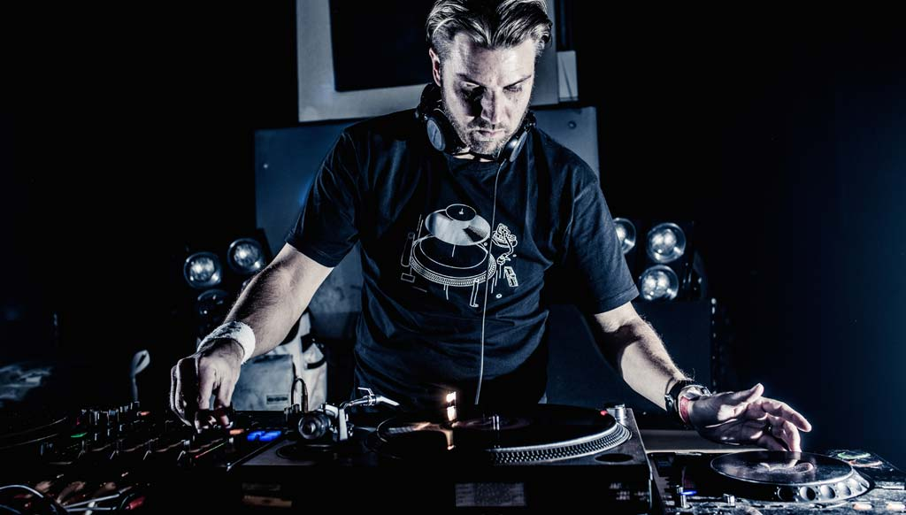

🚀 The Ultimate Finance & Blockchain Get-Together
TechClub 25/3 is where founders, investors, blockchain pioneers, decision makers, and disruptors exchange insights in an electrifying setting. The Chill-Out Lounge and the Unlimited Bar provide the perfect space to unwind, while the dancefloor keeps the energy sky-high. Also, all drinks and food are included with a ticket.
📅 Date & Time:
📍 When? March 25, 2025 (Tuesday), from 08:00 PM till late
📍 Where? TechQuartier, Platz der Einheit 2, 60327 Frankfurt, Germany
📍 What? Dance and high-level networking, all drinks and food are included.
📍 Tickets: https://lu.ma/mgc8n147
Why a Tuesday? Because we’re kicking off the excitement one day before the Crypto Assets Conference (CAC) — Germany’s big crypto conference. The official partners of TechClub 25/3 are the Frankfurt School Blockchain Center (FSBC) and the Crypto Assets Conference. All their speakers are invited to join TechClub 25/3 and will be brought to the venue.

💡 Who’s Behind TechClub?
TechClub is organized by Finance Loop in collaboration with TechQuartier and is supported by Solana, Frankfurt School Blockchain Center, dEURO Association, The Web3 Network, German Blockchain Week, Blockchain Bundesverband, BTC-ECHO, CONSTI, Superteam Germany, Finanzplatz Frankfurt Main, Web3 Talents, DLT Germany, FinTech FFM Meetups, STATION, Goki, Fintech Consult, EXPERT KEY, Frankfurt Forward, City of Frankfurt, Skyline Plaza, Entkorkte Kunst, and YARD. We’re an official partner of the Crypto Assets Conference 2025. Meet the who is who in on-chain finance... or dance!
Interested in sponsoring, having a private room, or hosting a pre-event? https://www.techclub.space/partnering/

🔥 Tickets are limited

This is an exclusive event with limited capacity. Don’t miss your chance to connect and celebrate with the industry’s elite.
🎟 Early Bird: 29€ per ticket (until March 23)
🎟 Last Minute: 39€ per ticket (from March 24)
The perfect place to relax and do high-level networking. All drinks and food are included.
➡️ Tickets: https://lu.ma/mgc8n147

Social Media Post Template
Europe’s Biggest Blockchain Networking Party 🎉
On March 25, Frankfurt becomes the epicenter of blockchain technology and digital assets! TechClub 25/3 brings together pioneers, investors, decision-makers, and disruptors for an unparalleled night of networking and celebration. Legendary DJ Tom Wax will take over the Moonshot Arena, setting the tone with his iconic electronic beats.
• Chill-Out Lounge & Unlimited Bar – Network, recharge, and enjoy.
• Dancefloor Vibes – High-energy beats, high-impact connections.
• All drinks & food included with your ticket.
Meet the who’s who of on-chain finance – or just dance. Finance Loop and its partners welcome you at TechQuartier, Germany’s largest FinTech hub.
🔥 More details & tickets: https://lu.ma/mgc8n147
#techclub #crypto #networking #blockchainparty #frankfurt #web3

Organizing Team of TechClub 25/3
📩 Press & Media Inquiries: team@techclub.space
🌐 More Details: https://www.techclub.space/2025/03/11/press-release/
📞 Phone: +496987001246
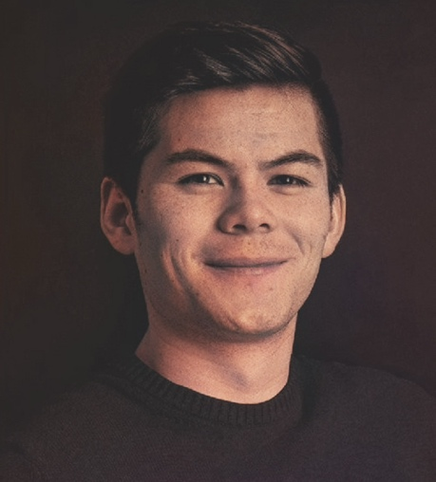 | 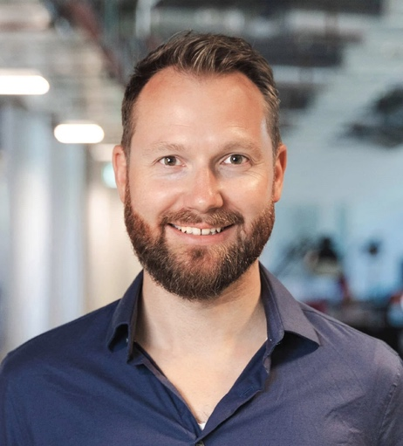 | 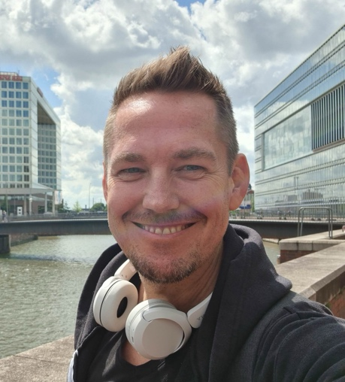
Thomas Bolleyer  Send an email  LinkedIn - Telegram | Sören Eversmeier  Send an email  LinkedIn - Telegram | Michael Wutzke  Send an email  LinkedIn - Telegram
